CS 255 System Design Document Template

UML Diagrams
UML Use Case Diagram
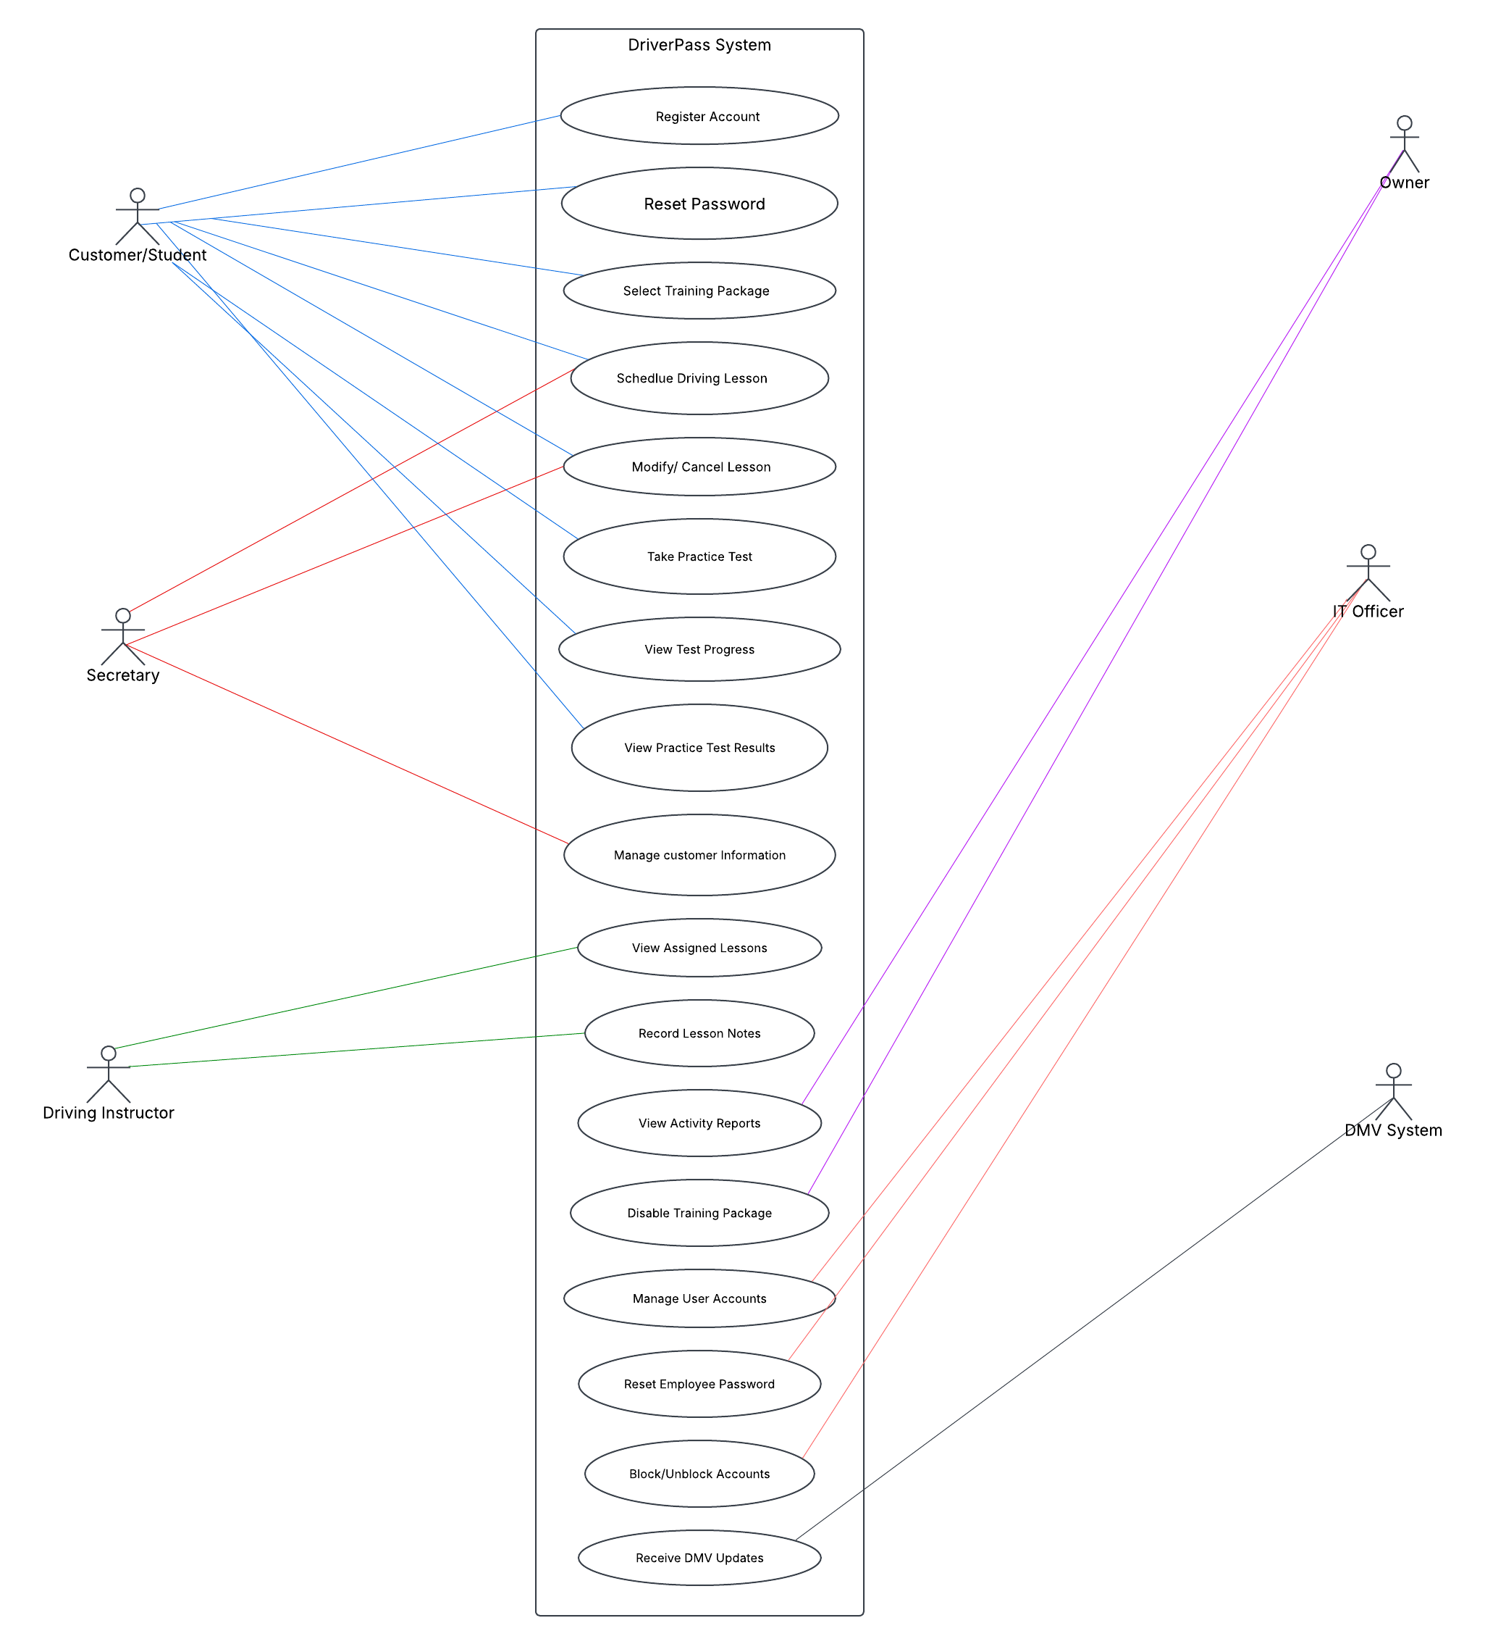

Sequence Diagram

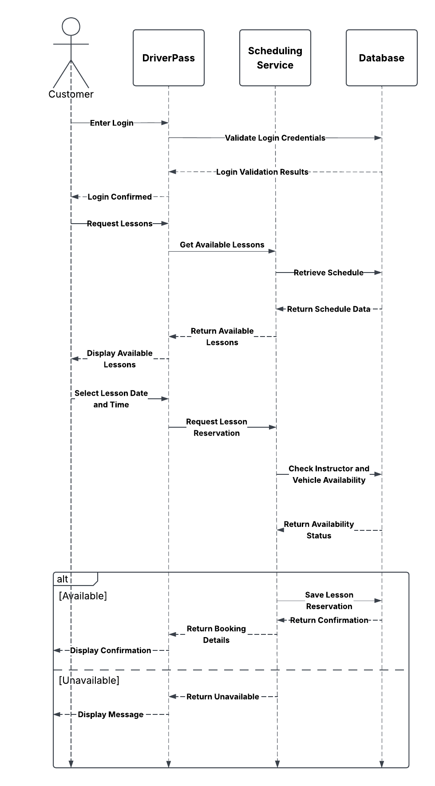

Schedule Driving Lesson Activity Diagram

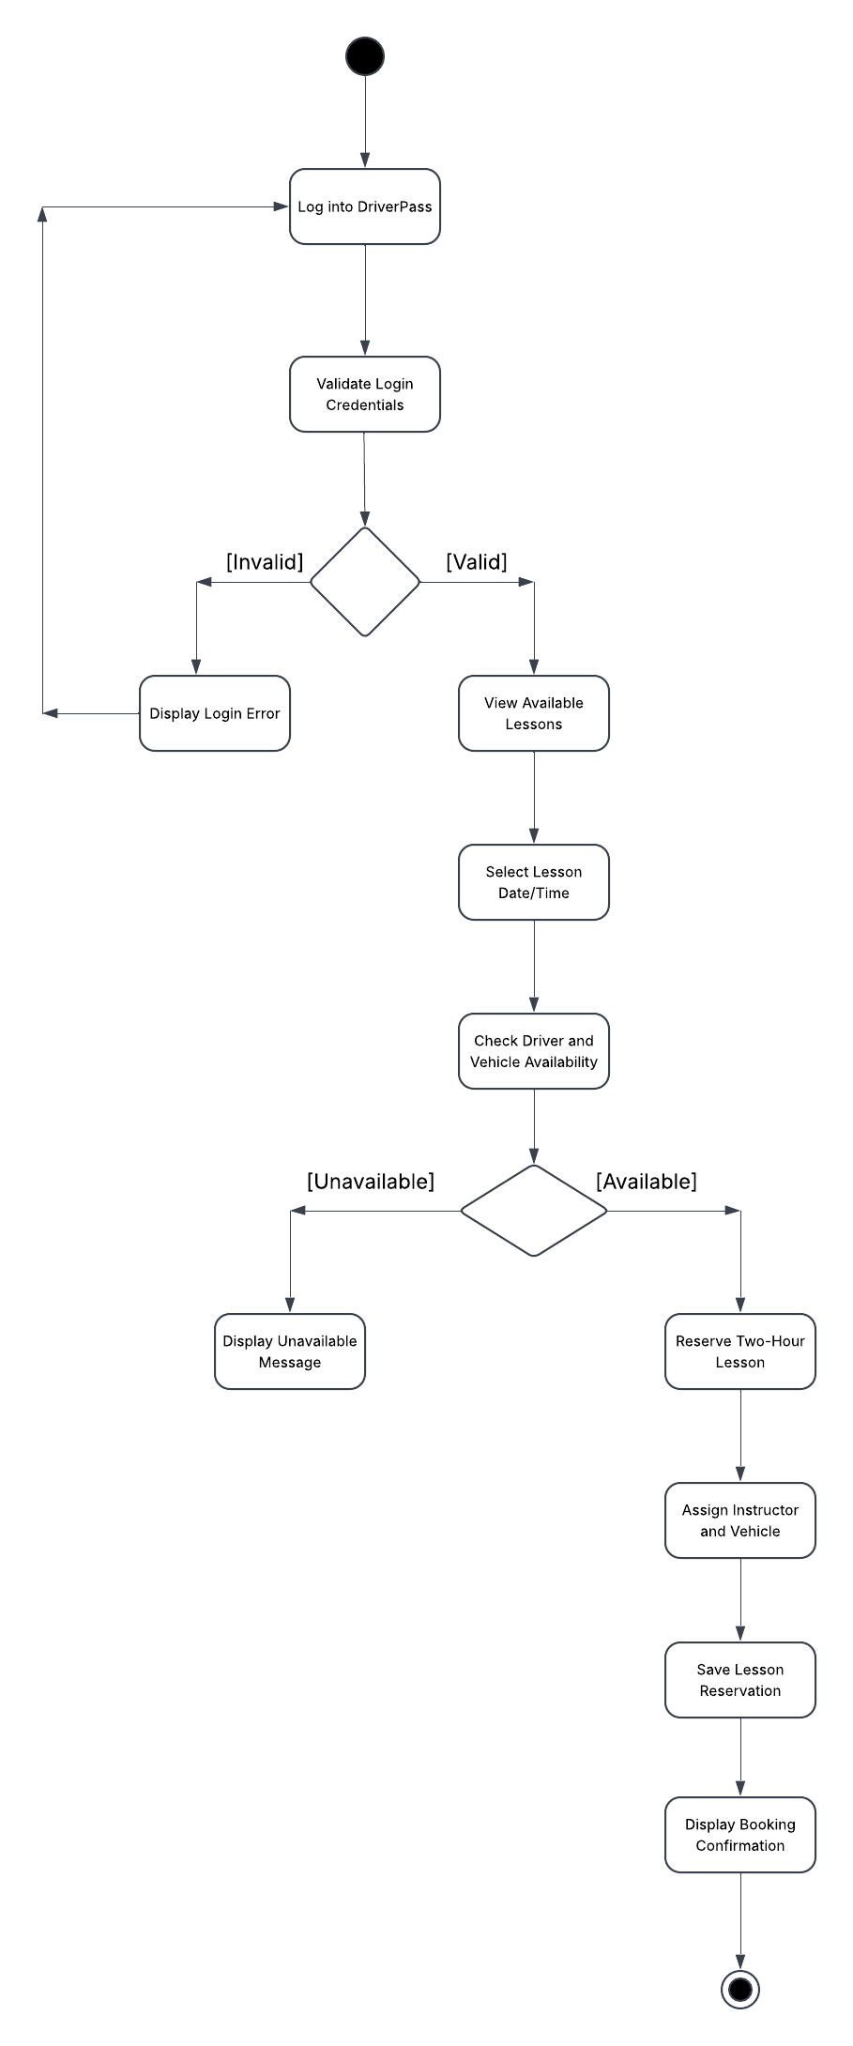

UML Take Practice Test Activity Diagram
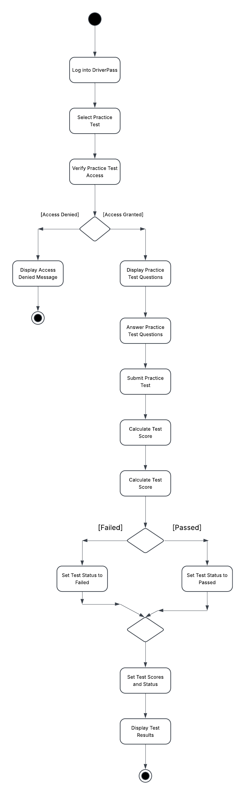

UML Class Diagram
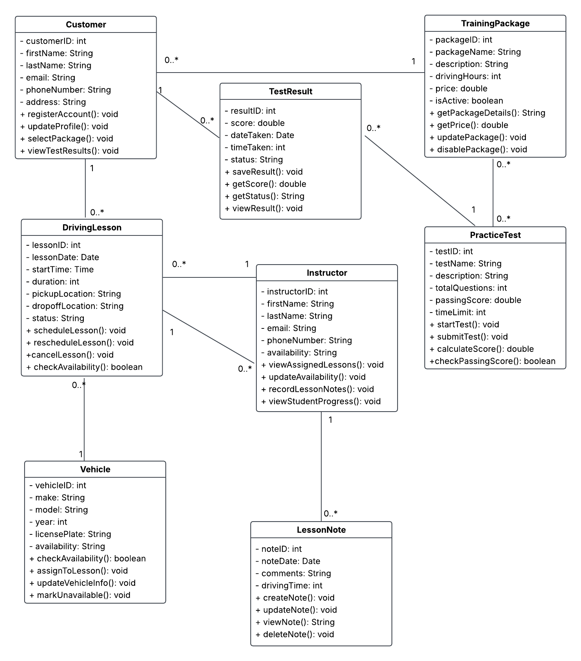

Technical Requirements

The DriverPass system will need reliable hardware, software, and network infrastructure to support its daily operations. Since the system will be cloud-based, customers and employees will be able to access it through a web browser using a computer, tablet, or smartphone. DriverPass employees will also need computers and a reliable connection to the internet to manage appointments, customer records, and other business information. This will allow customers to register for accounts, select training packages, schedule driving lessons, and complete practice tests without installing additional software.
The system will need a web application, a database, and a secure cloud hosting service. The database will store customer information, training packages, instructor schedules, vehicle assignments, lesson notes, and practice test results. Keeping this information in one central database will allow customers and employees to work with the same updated information. The application will also need scheduling features that check instructor and vehicle availability to help prevent double bookings.
Security will be another important requirement. DriverPass will need password-protected accounts, encrypted connections, and role-based access controls so employees and customers can only access information related to their responsibilities. Regular data backups will also be necessary to protect important records. The system should support updates to DMV information and allow authorized employees to generate reports that can be downloaded and opened in Microsoft Excel.
During development, Lucidchart can be used to create and maintain UML diagrams, while a programming environment, database management tools, and testing tools will be needed to build and test the application. Together, these technologies will help DriverPass provide a secure, accessible, and reliable service for its customers and employees.

